EXERCISE 1: CONTROL STRUCTURES

**Scenario 1:** Write a PL/SQL block that scans through all customers, checks their age, and applies a 1% discount on their loan interest rates if they are over 60 years old.  
  
DECLARE

CURSOR senior_customers IS

SELECT CustomerID, (SYSDATE - DOB)/365 AS Age

FROM Customers

WHERE (SYSDATE - DOB)/365 > 60;

BEGIN

FOR customer IN senior_customers LOOP

UPDATE Loans

SET InterestRate = InterestRate - 1

WHERE CustomerID = customer.CustomerID;

END LOOP;

COMMIT;

END;

/

**OUTPUT**

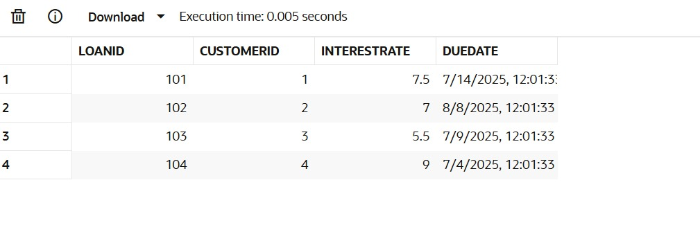

**Scenario 2:** Write a PL/SQL block that iterates through all customers and marks those with a balance over $10,000 as VIP.  
  
BEGIN

FOR customer IN (SELECT CustomerID FROM Customers WHERE Balance > 10000) LOOP

UPDATE Customers

SET IsVIP = 'TRUE'

WHERE CustomerID = customer.CustomerID;

END LOOP;

COMMIT;

END;

/

**OUTPUT**  
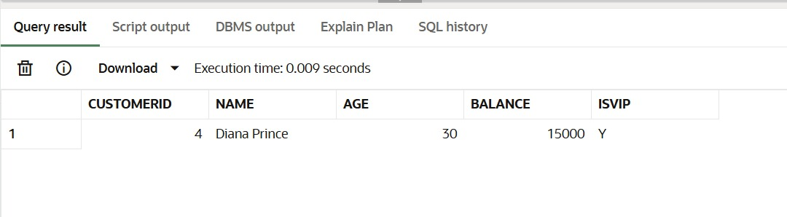

**Scenario 3:** Write a PL/SQL block that fetches loans due in the next 30 days and prints a reminder message for each customer.  
  
DECLARE

CURSOR due_loans IS

SELECT LoanID, CustomerID, EndDate

FROM Loans

WHERE EndDate BETWEEN SYSDATE AND SYSDATE + 30;

BEGIN

FOR loan IN due_loans LOOP

DBMS_OUTPUT.PUT_LINE('Reminder: Loan ID ' || loan.LoanID || ' for Customer ID ' || loan.CustomerID || ' is due on ' || loan.EndDate);

END LOOP;

END;

/

**OUTPUT**